**PRACTICAL: 3**

**IMPLEMENTING PRIVATE CLOUD WITH XEN SERVER**

**Steps:**

1.Open VMware Workstation – And select Create a New Virtual Machine

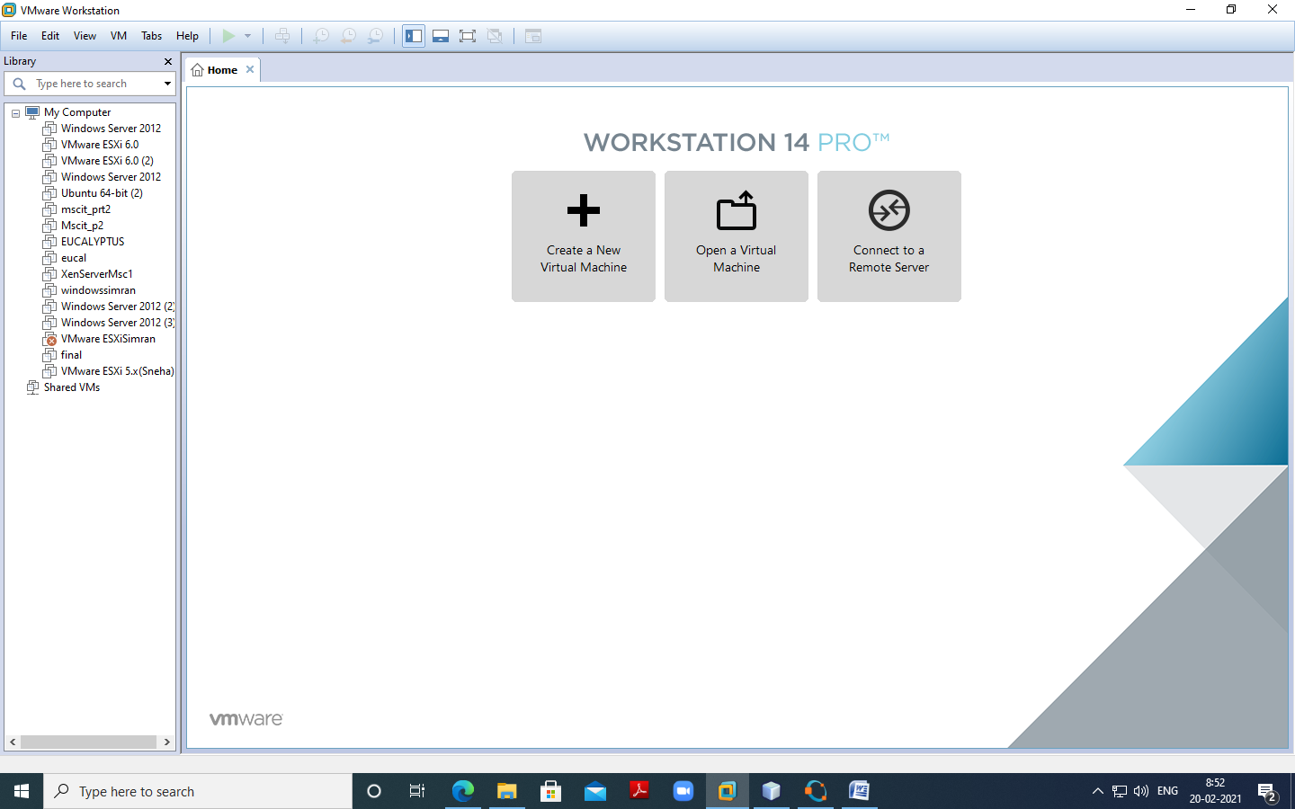

2.Select Typical and click Next

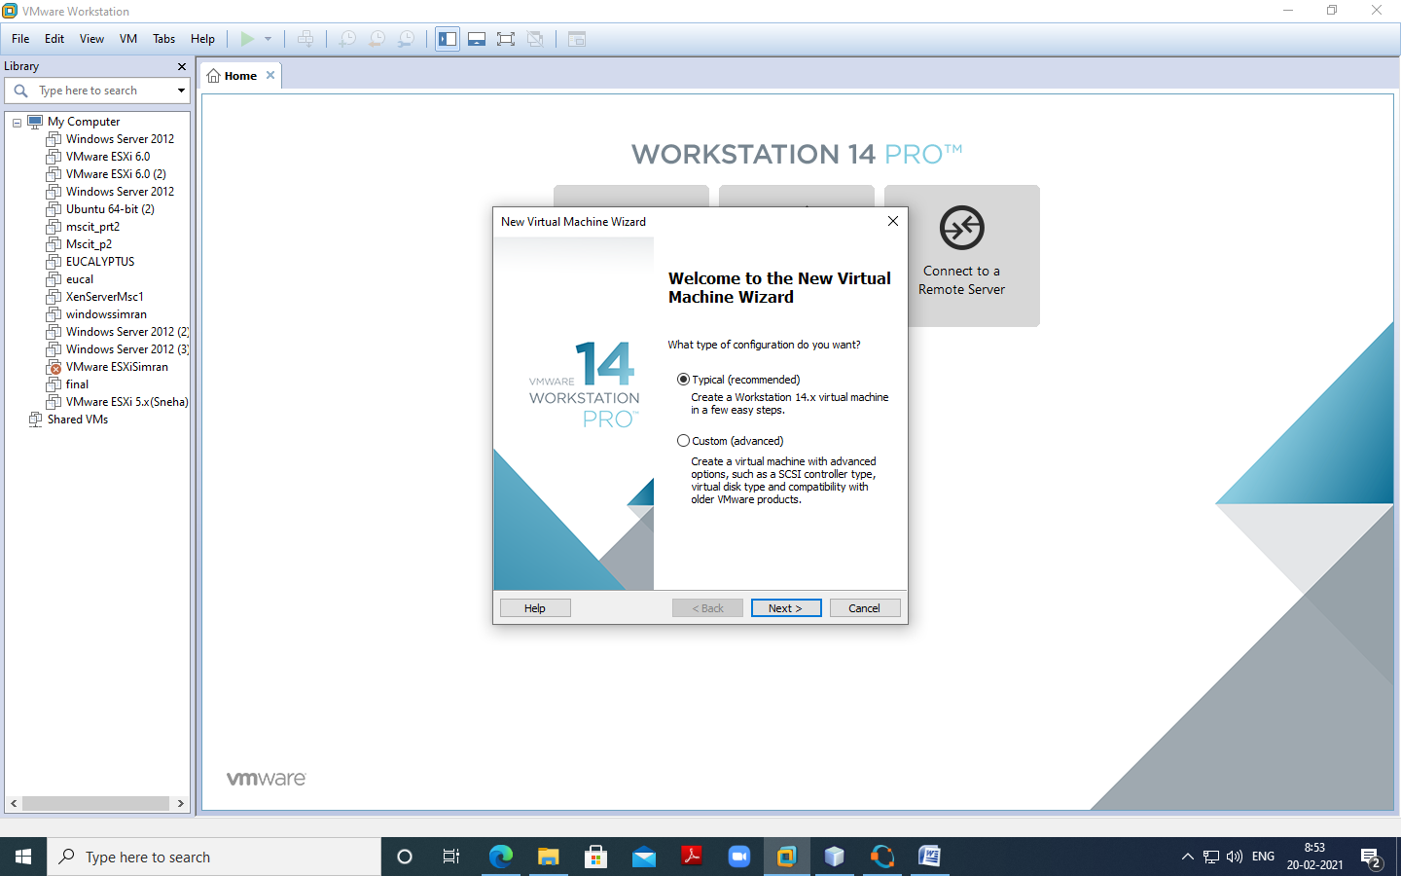

3.Select Installer disc_image file(ISO). Click Browse - XenServer Iso File – For

Example “D:\ccpraxrj\XenServer-6.2.0-install-cd.iso”

And click on next

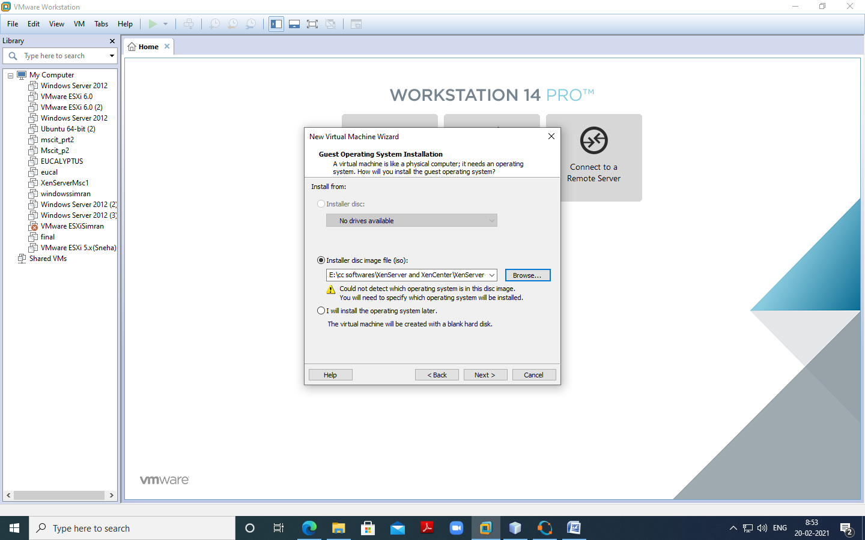

Select Guest Operating system as Linux. Version as Ubuntu. Click Net.

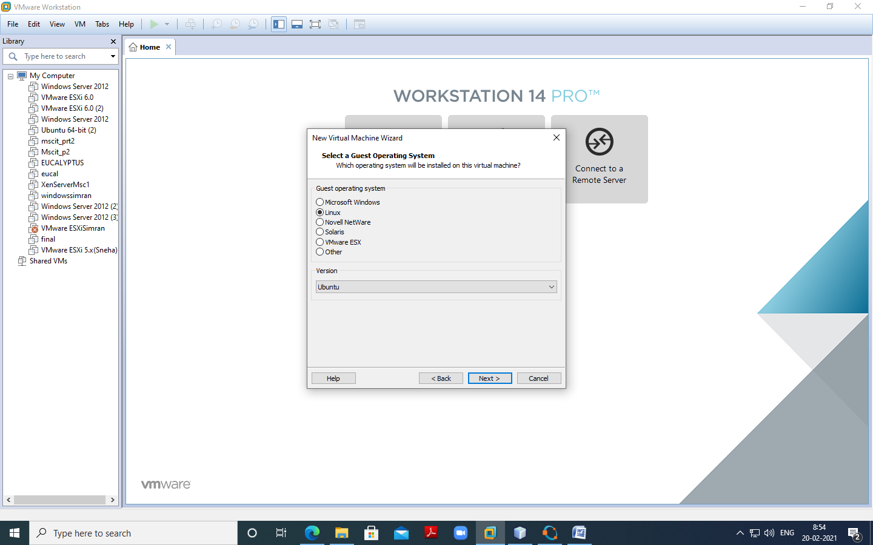

Give Virtual name – for Example “XenServerInst” and click on next

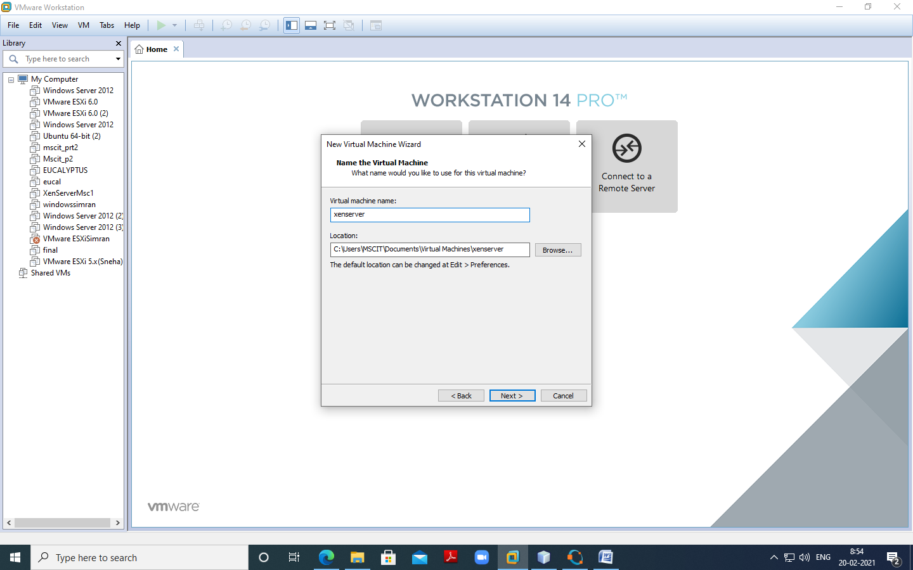

Change maximum disk size to 40 GB and check –Store virtual disk as single file

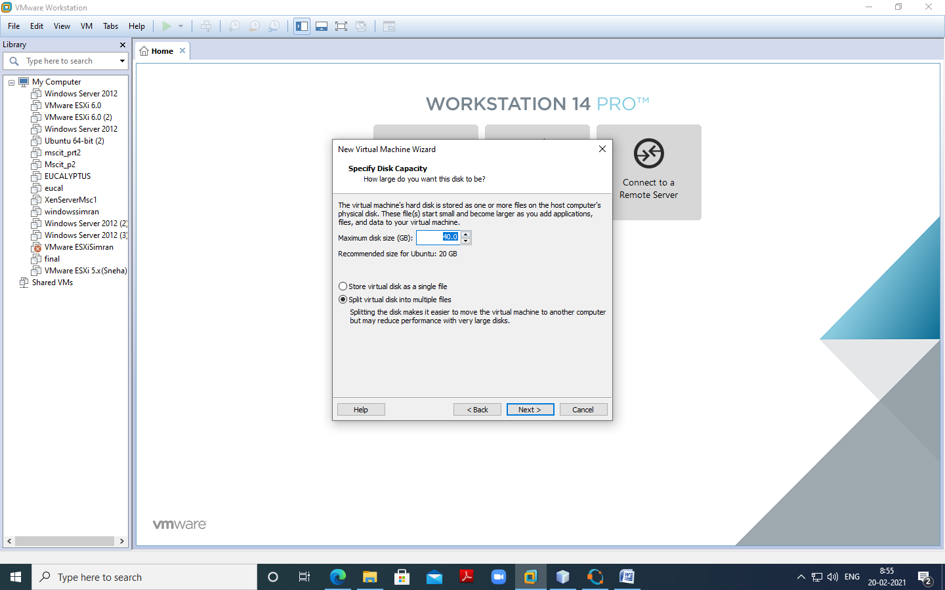

4.Click on Customize Hardware option

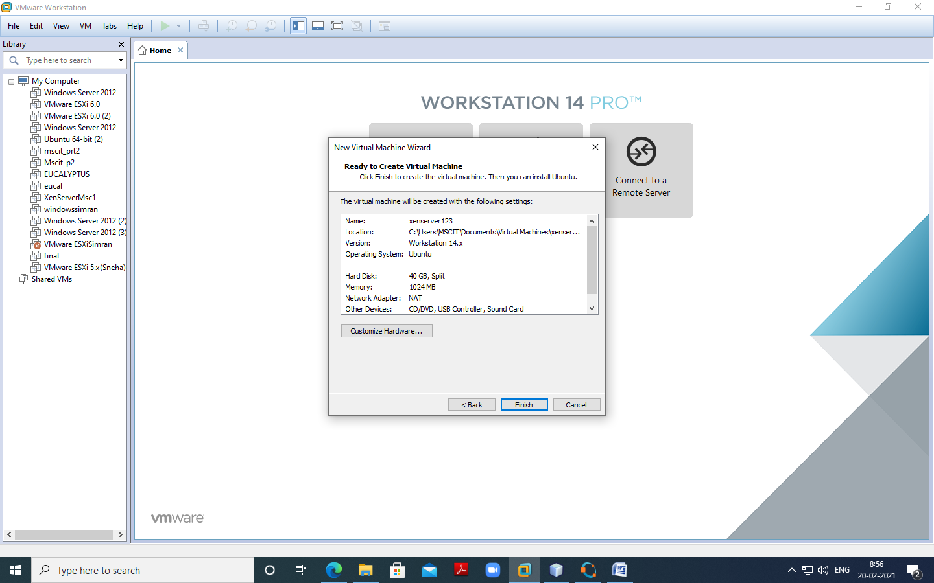

Change – Memory for this virtual machine to 2 GB and click on close

Click on Processer and select virtualize Intel VT

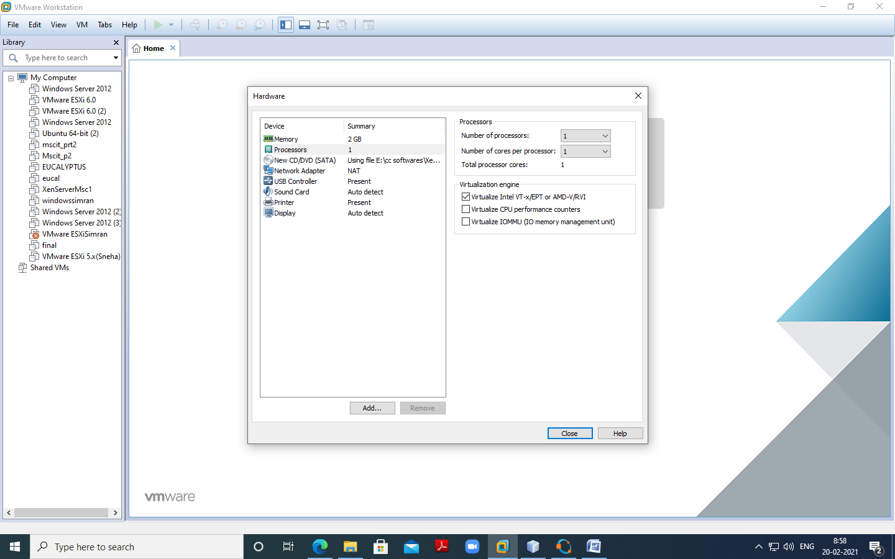

Click on Finish –

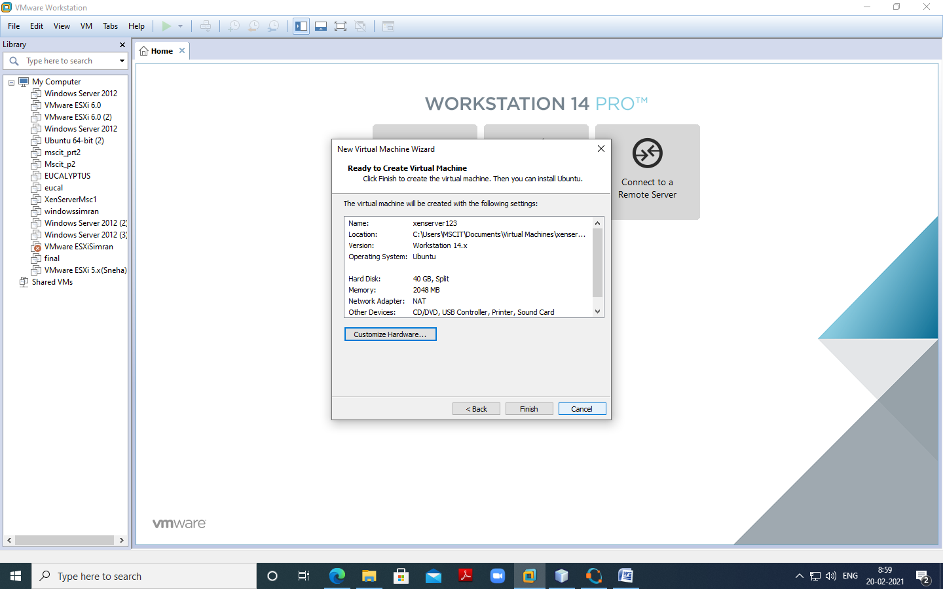

Now Power on newly created Virtual machine –

Now select US and click on OK

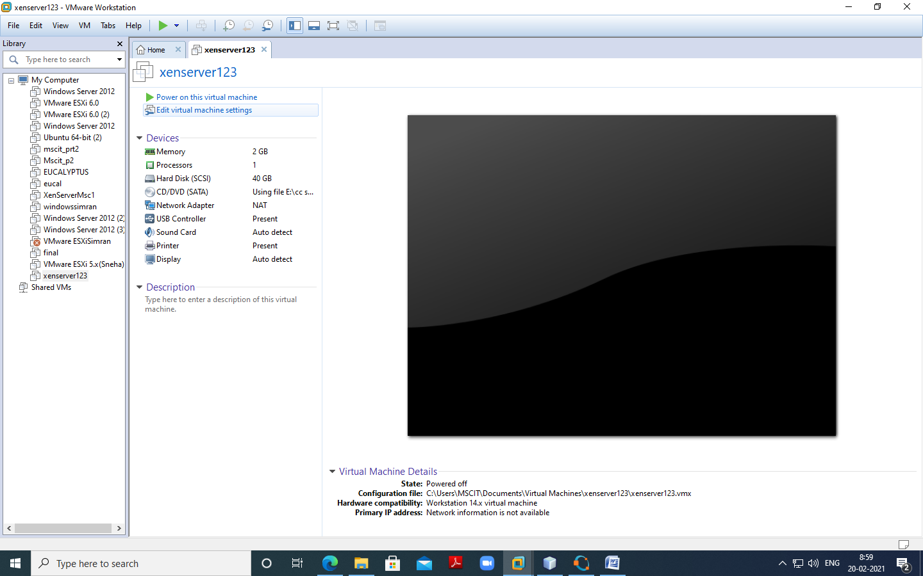

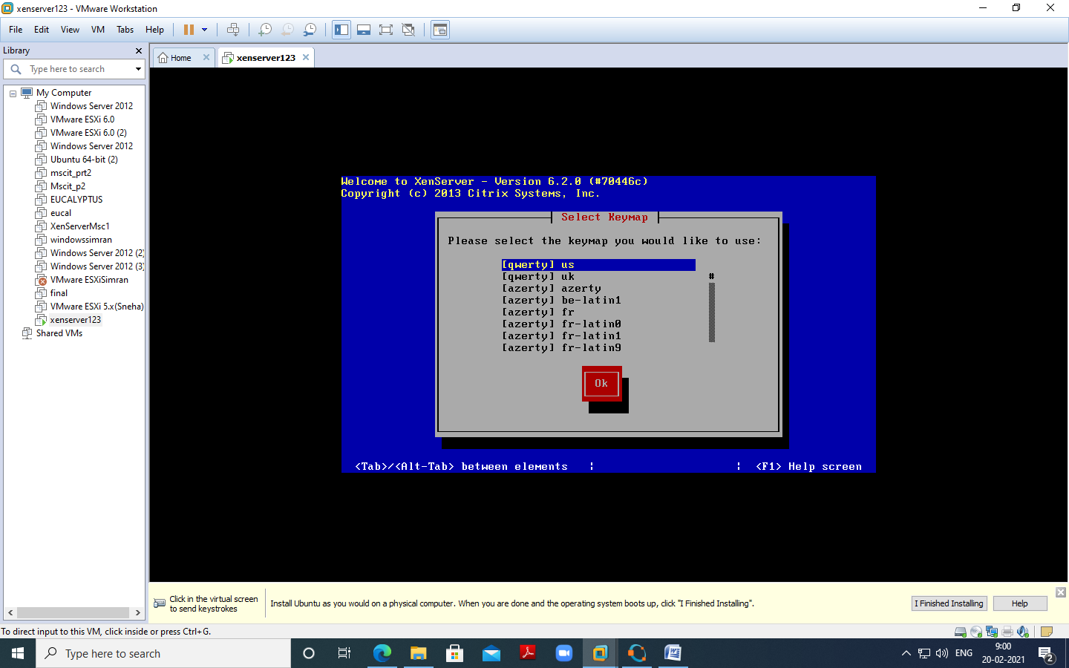

Click on OK as seen in below screenshot

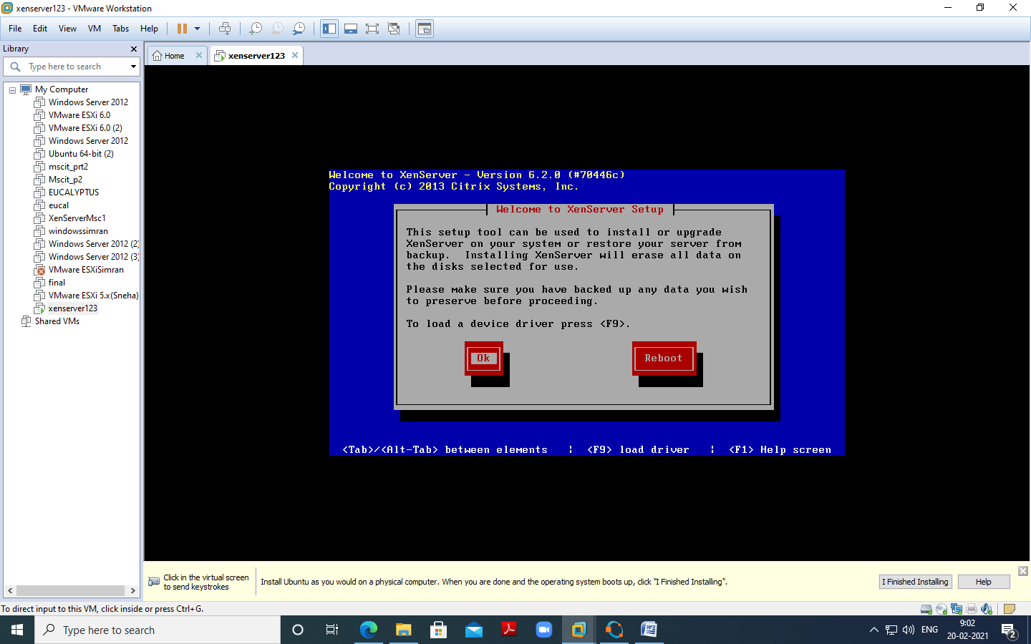

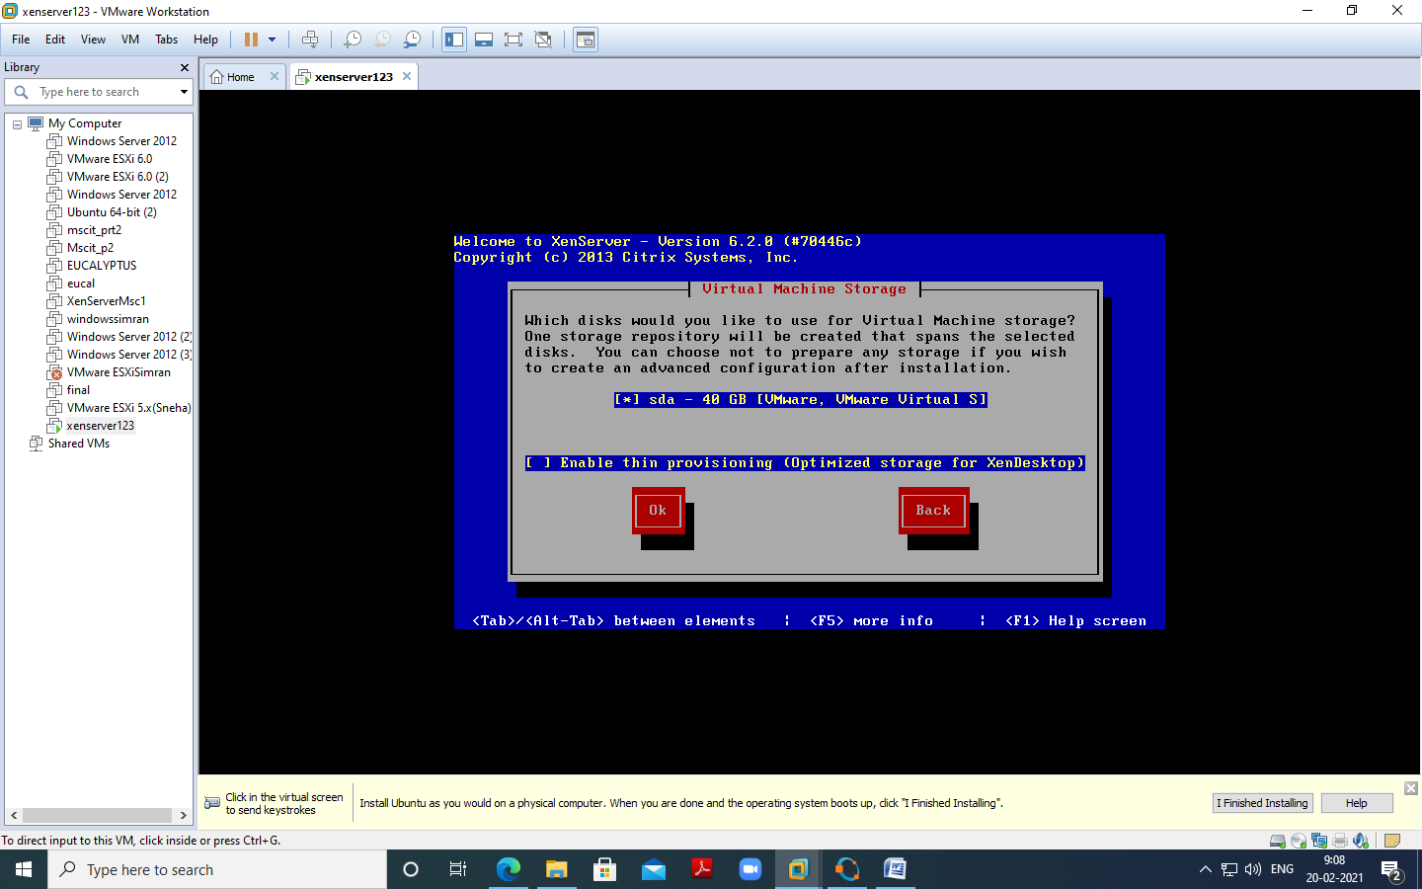

Select Local media and ok

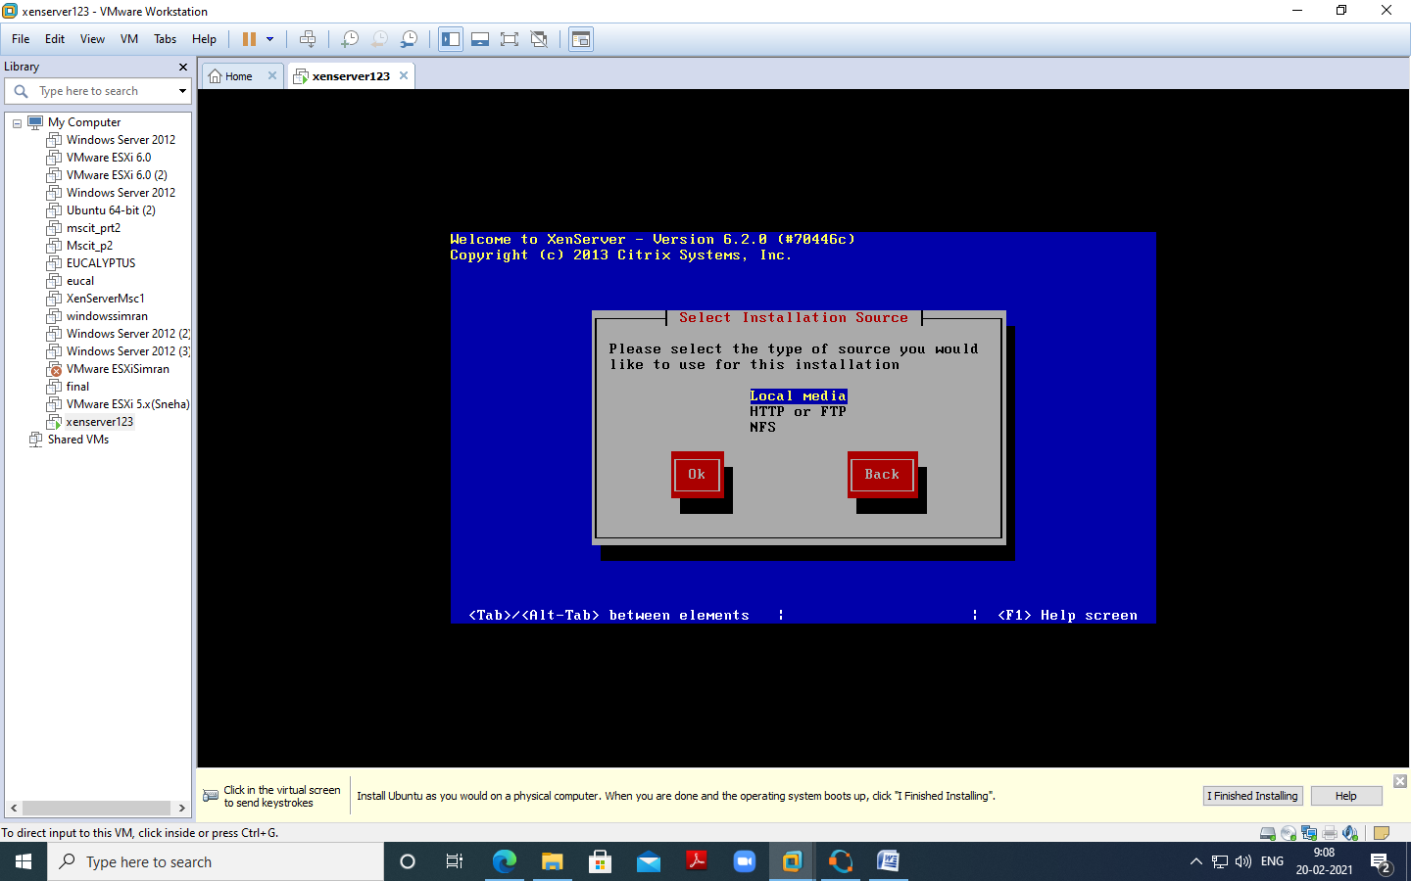

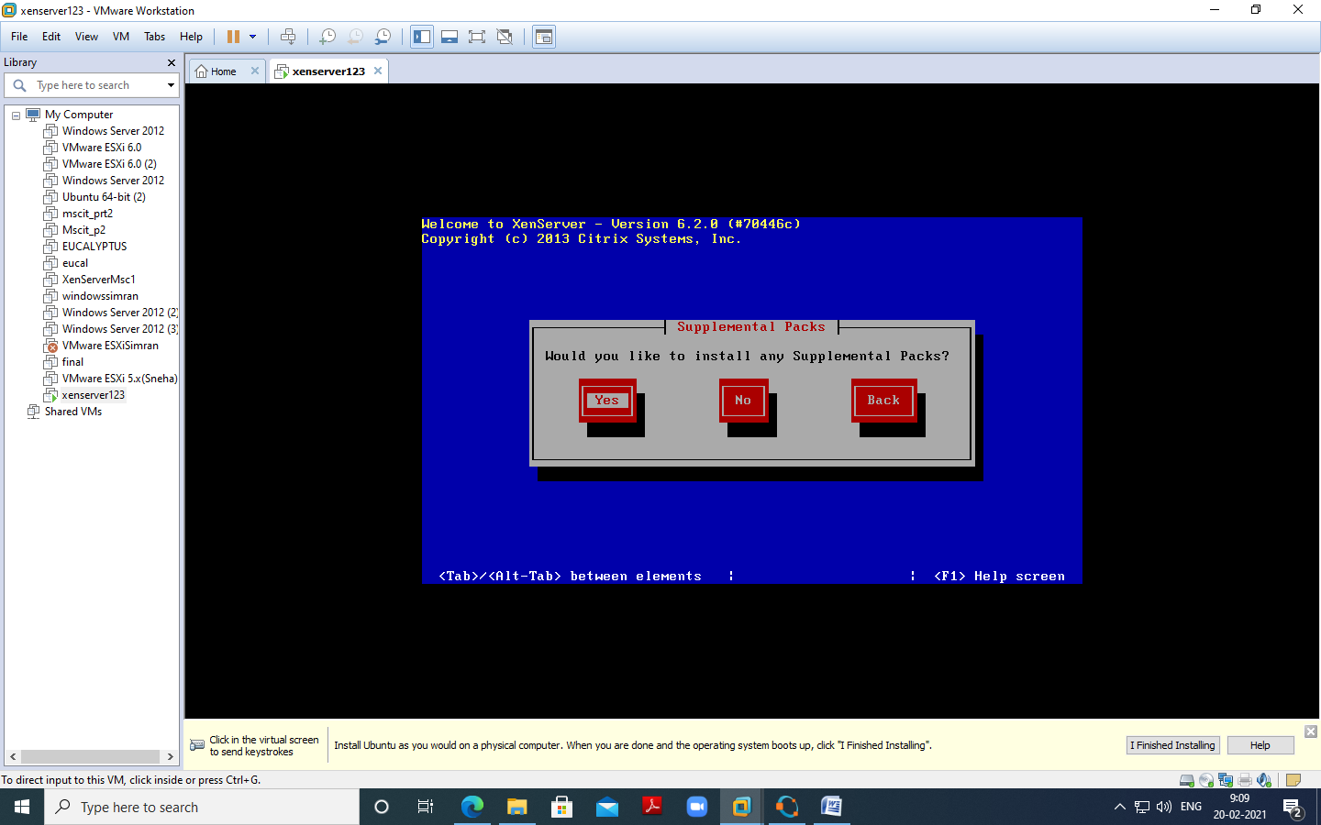

Here click verify installation

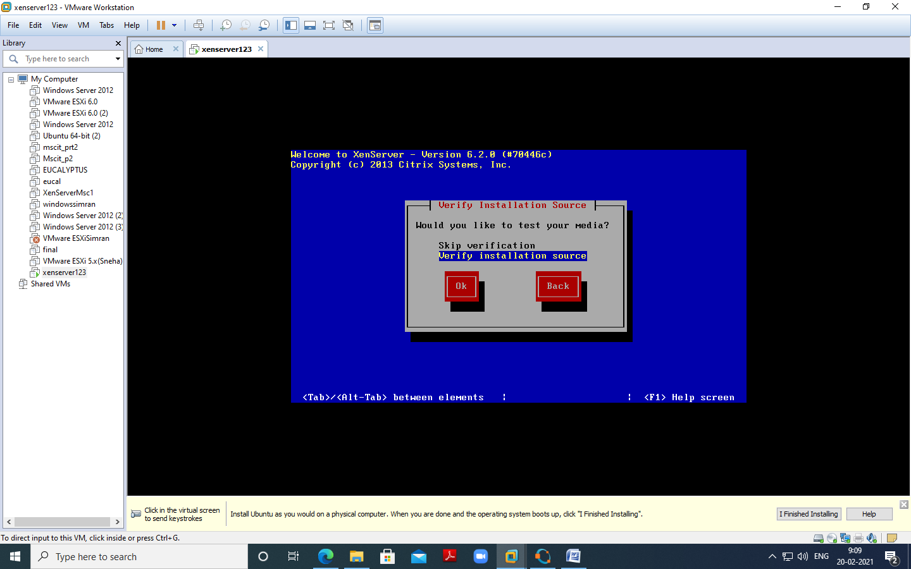

Click on “OK”

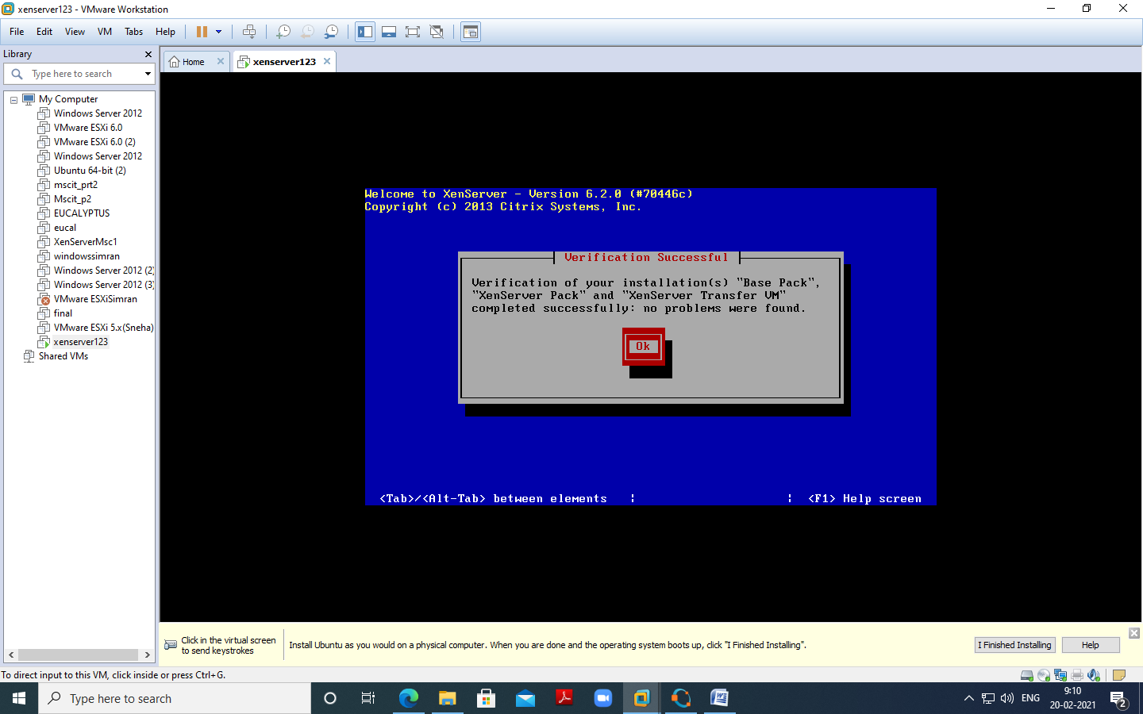

Insert password (Remember password entered) and click on Ok –

Password:root123

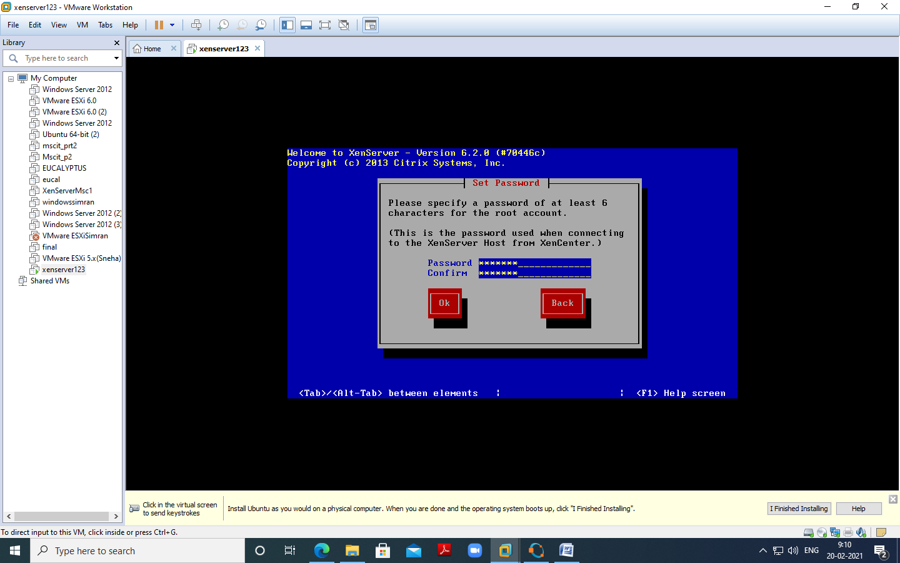

Select Automatically set via DHCP and click on OK

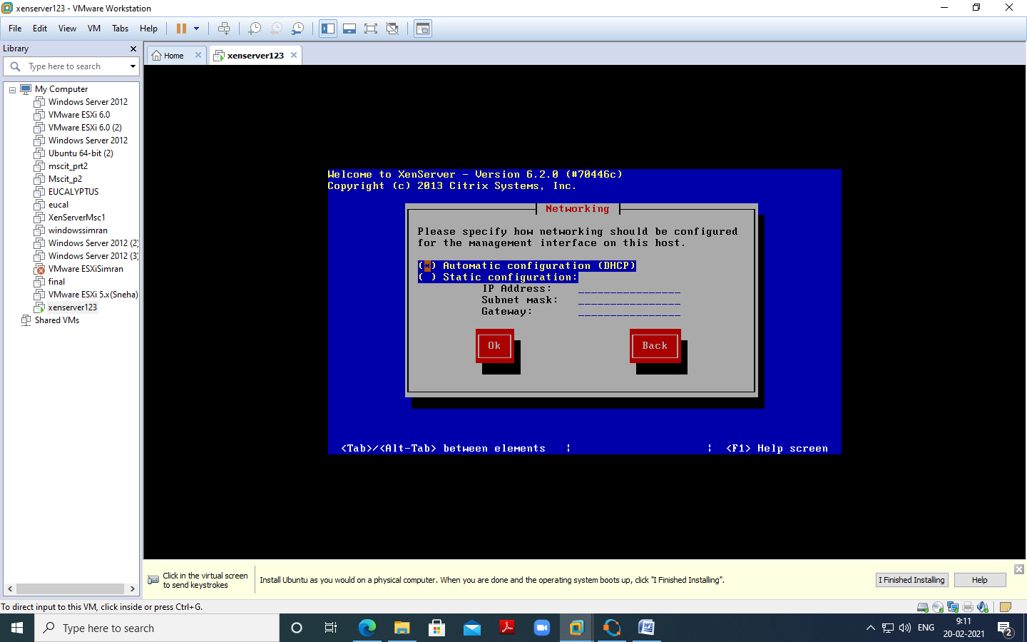

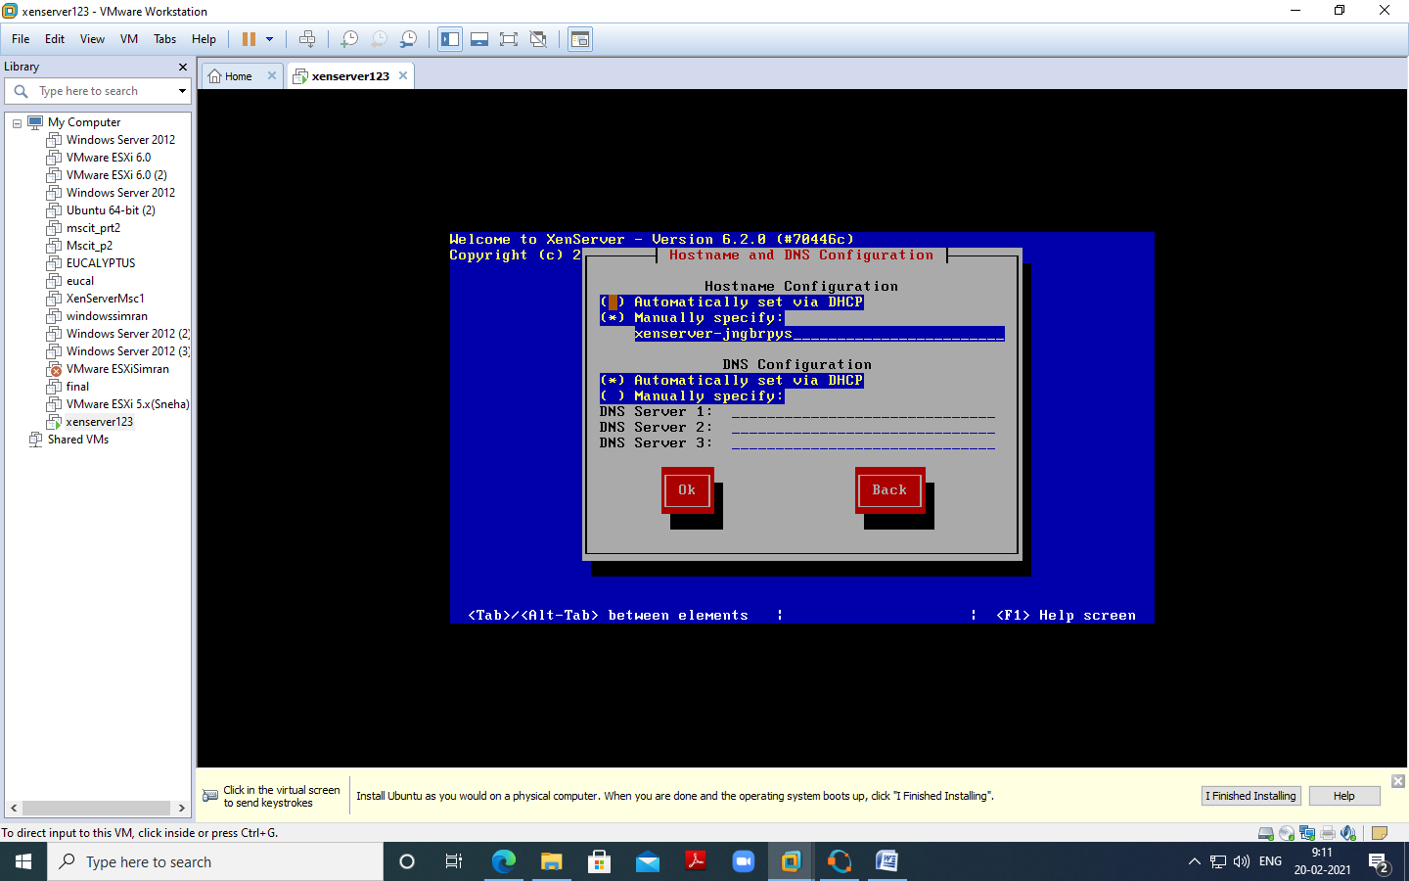

Select Asia and click on OK –

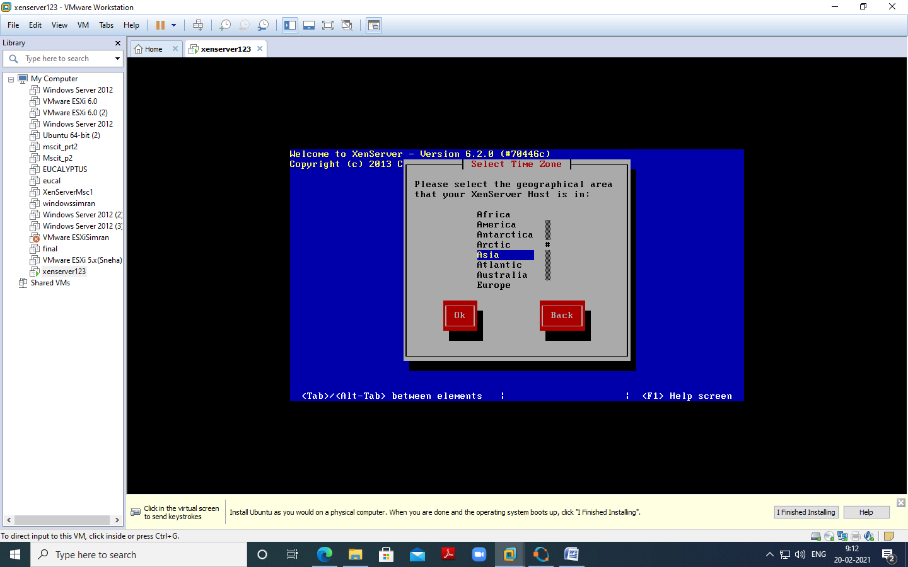

Select Calcutta

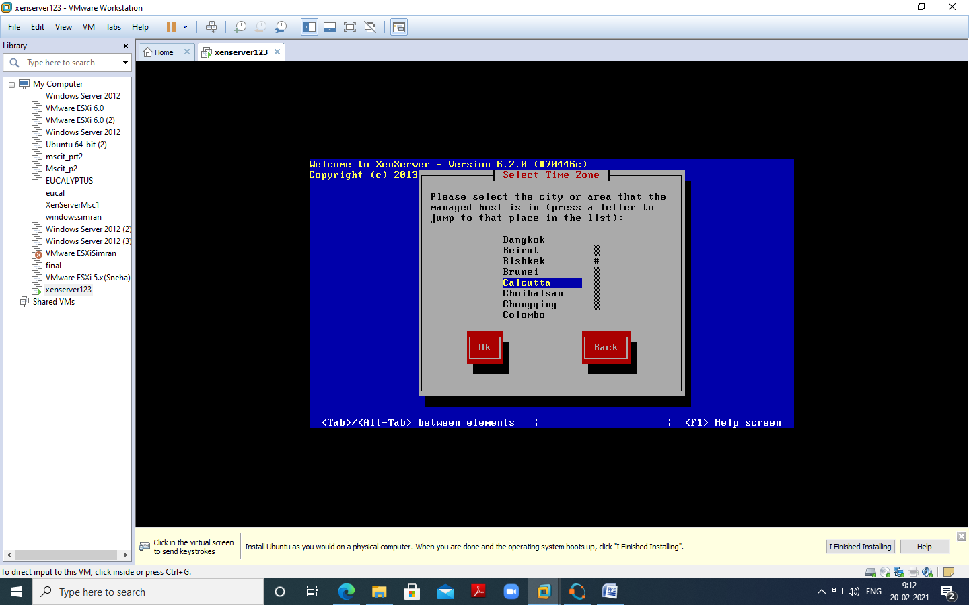

Select “Using NTP” and click on OK

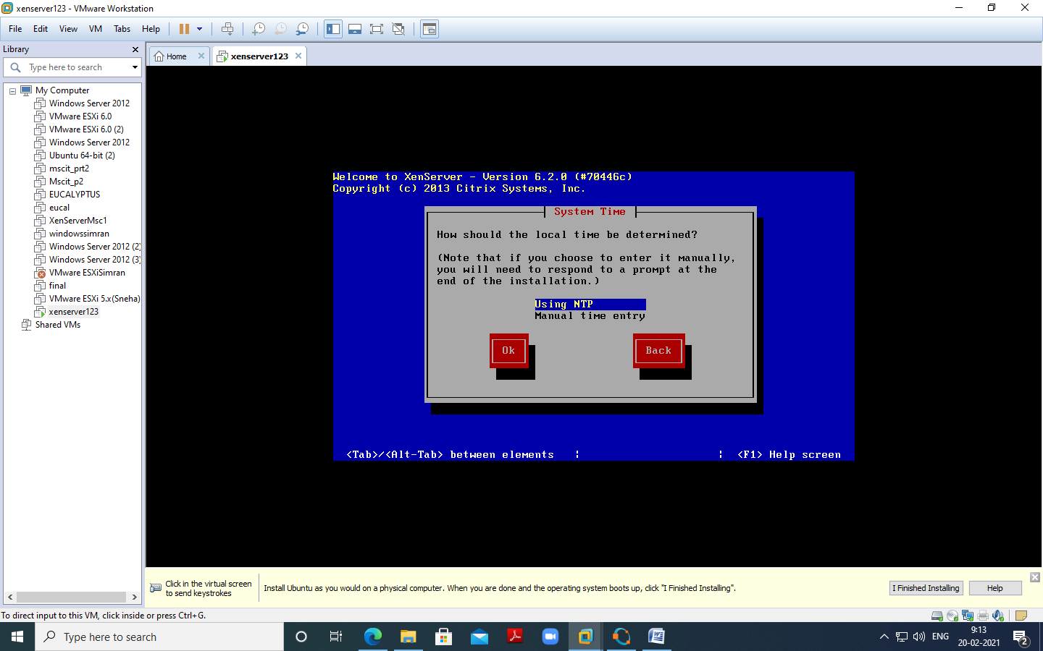

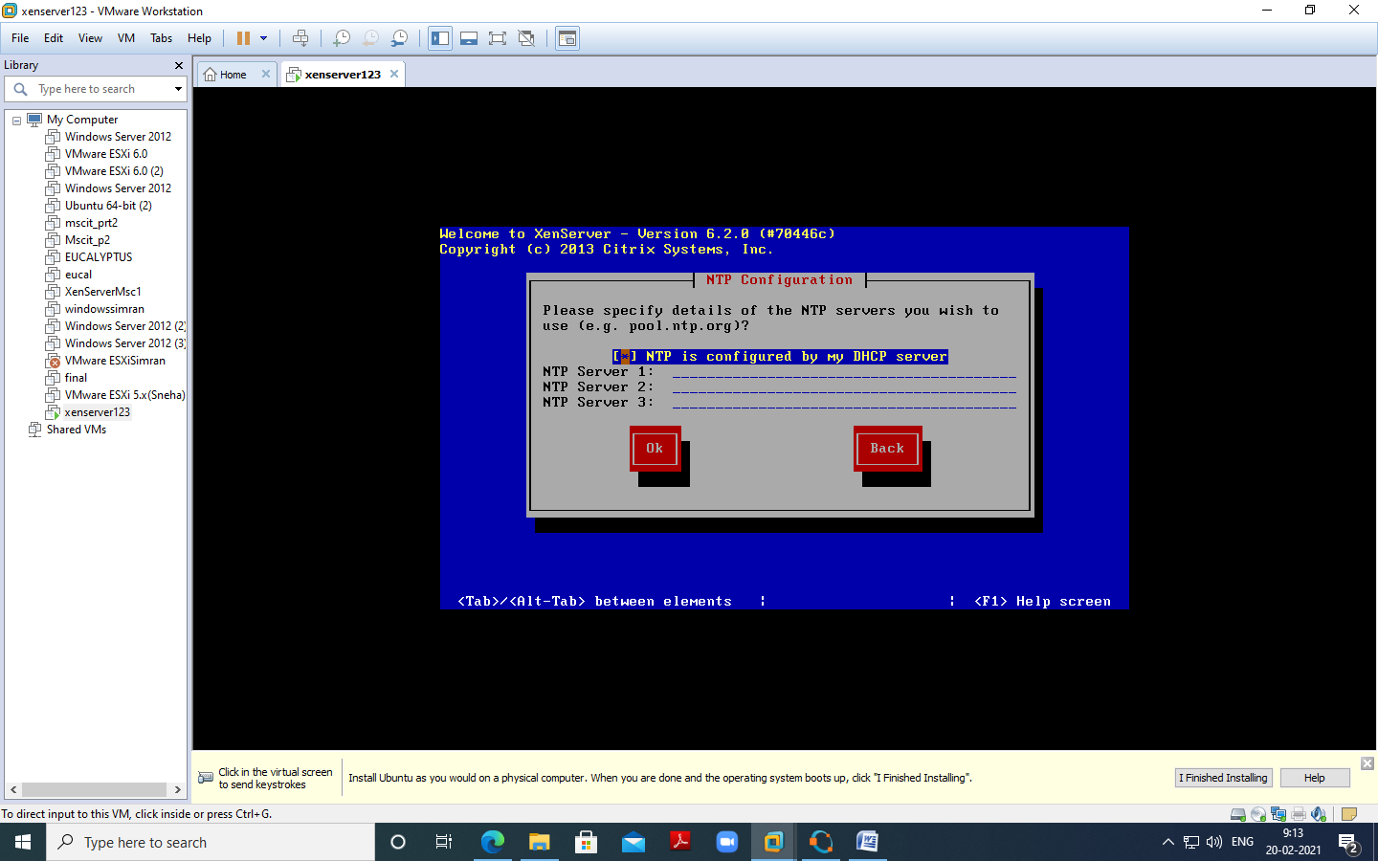

Click Install Xen server

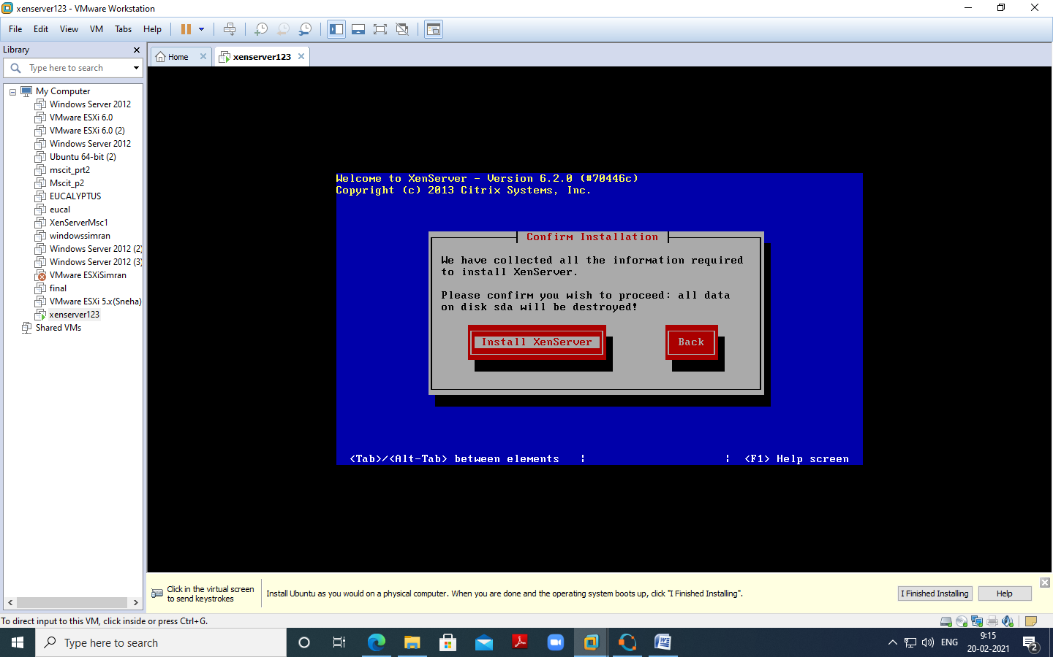

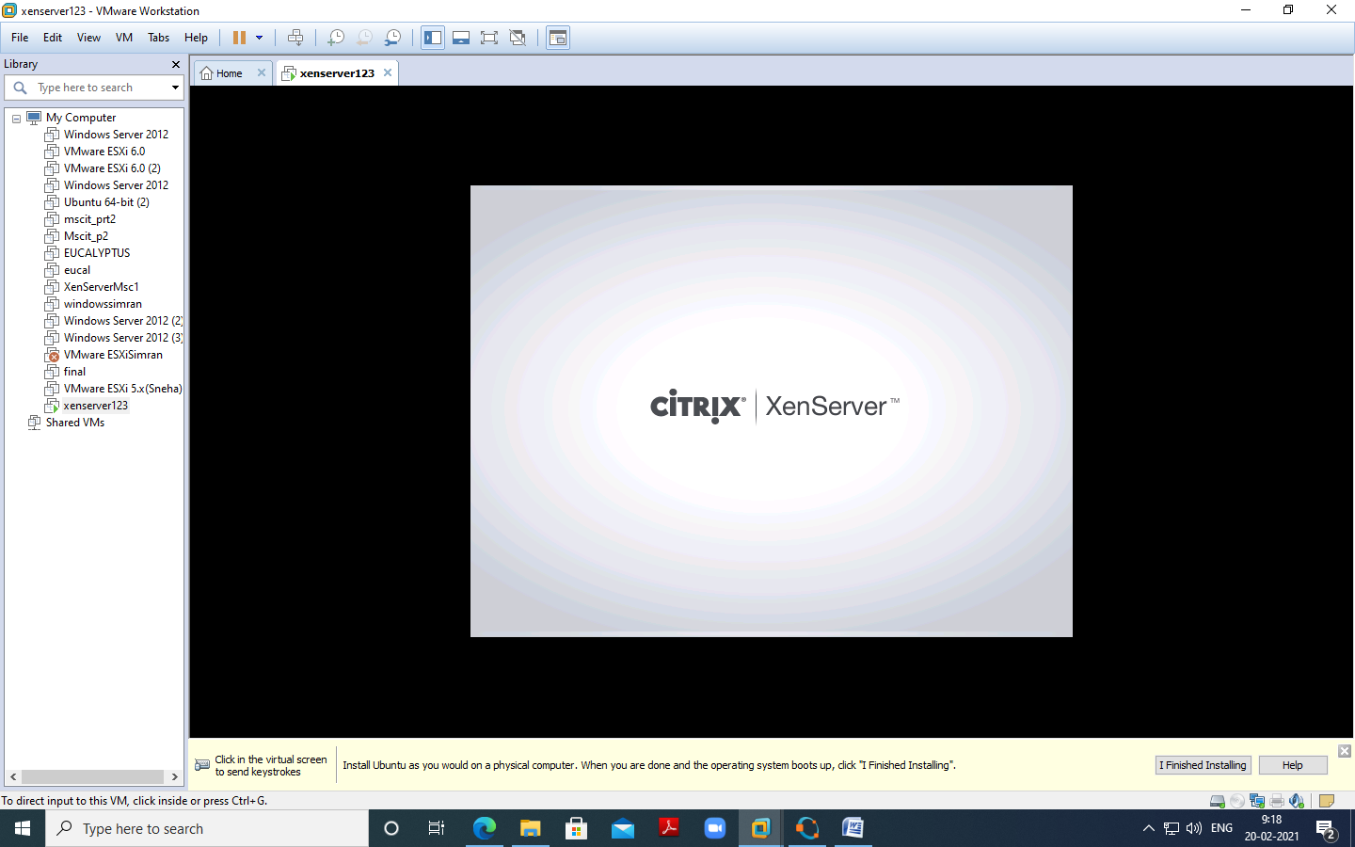

Note IP Addres – “ 192.168.208.144” ping it from command prompt

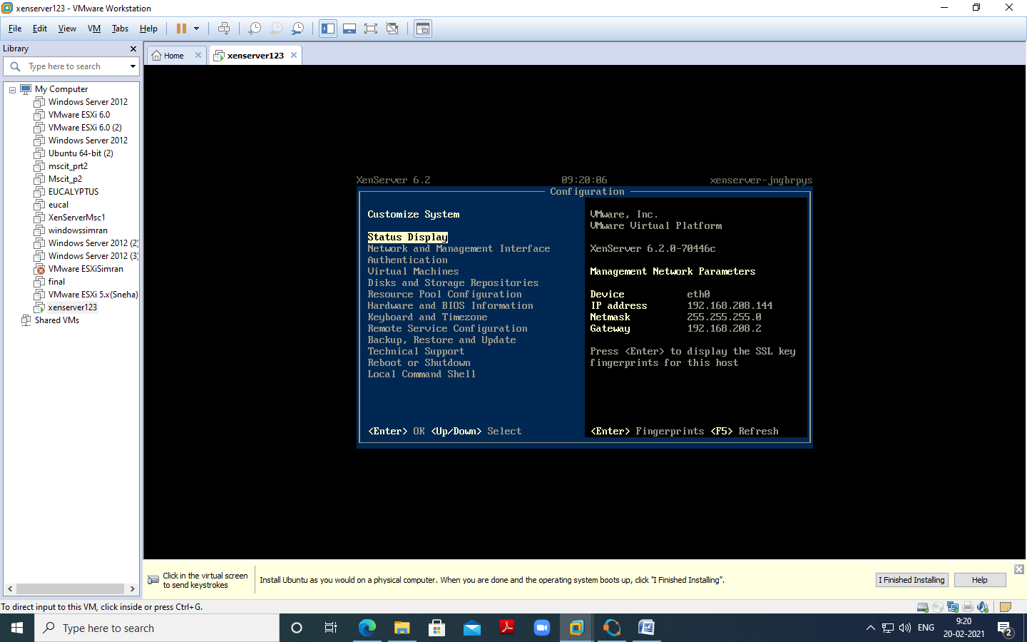

5.Now Open Citrix XenCenter – and Click and Add Server

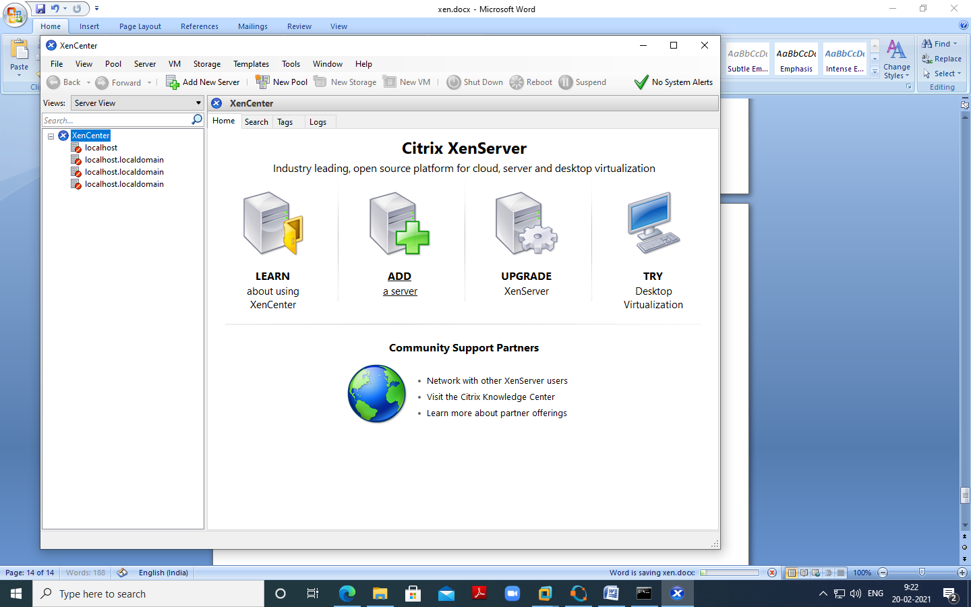

Fill IP address copied from Installation and User name as “root” and Password

as “root123” which we had given during installation and Click on Add

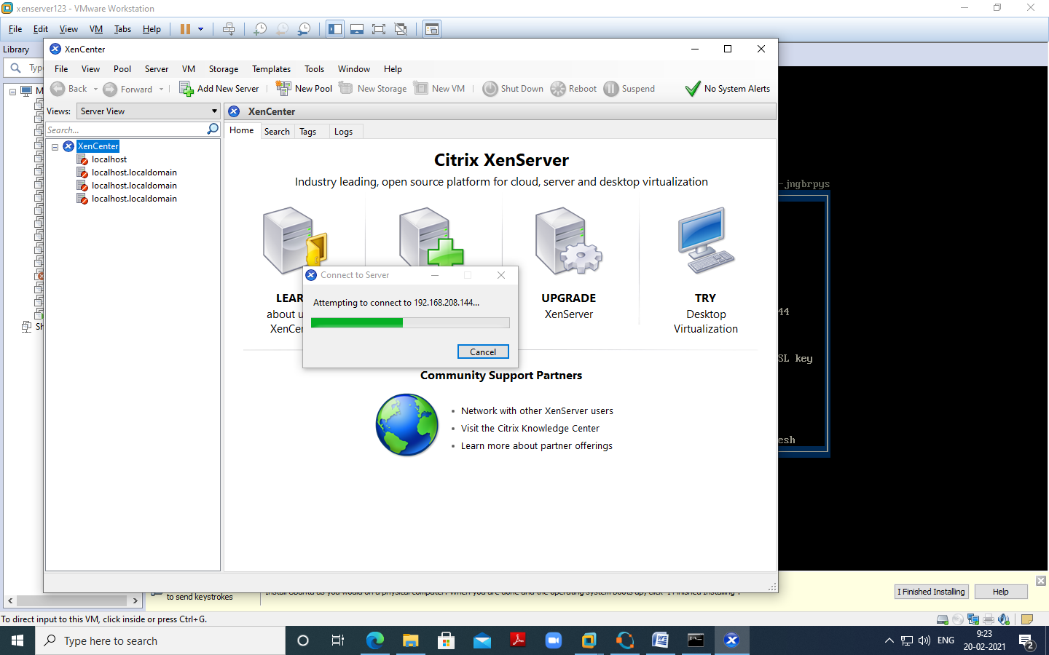

Now Click on New Storage –

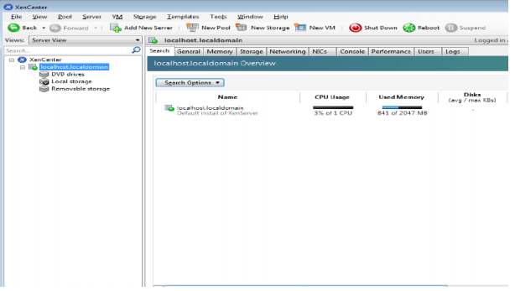

Select Window File Sharing (CIFS) and click on next –

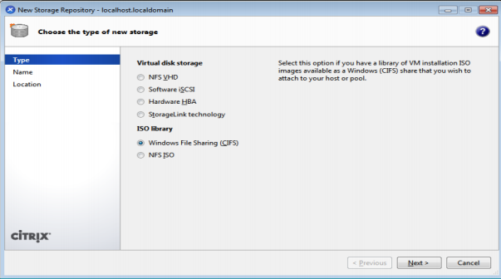

Uncheck Auto generate option Click on Next

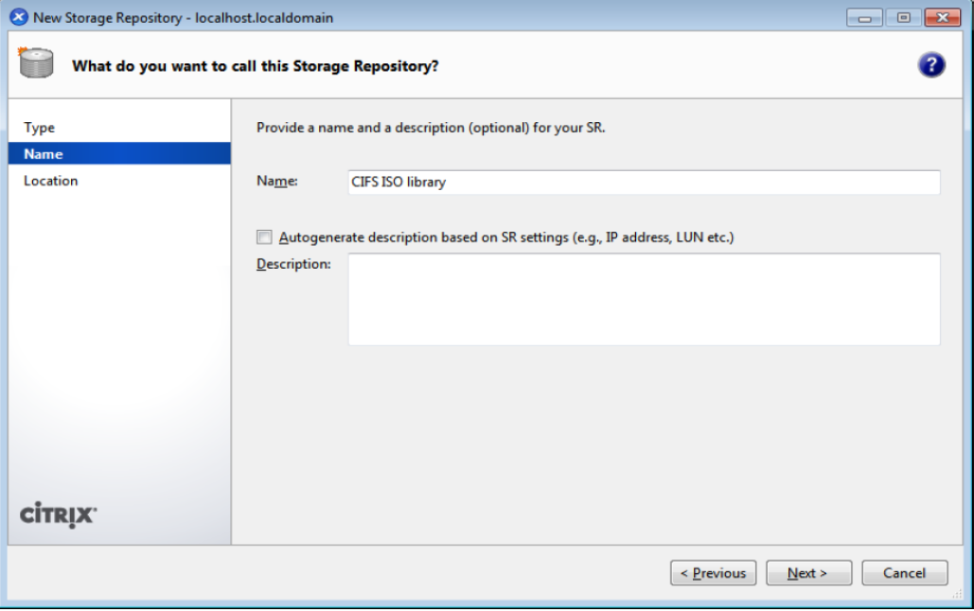

Provide the path of shared windows XP image and enter local pc credential ,, click on Finish

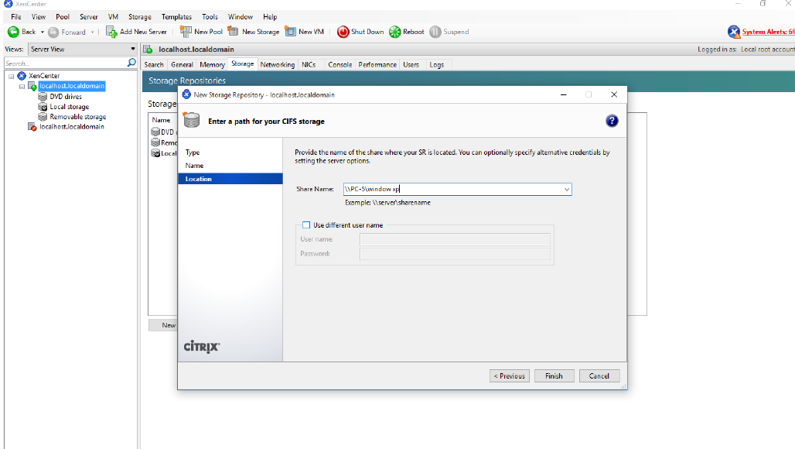

Click on New VM – and Windows XP SP3

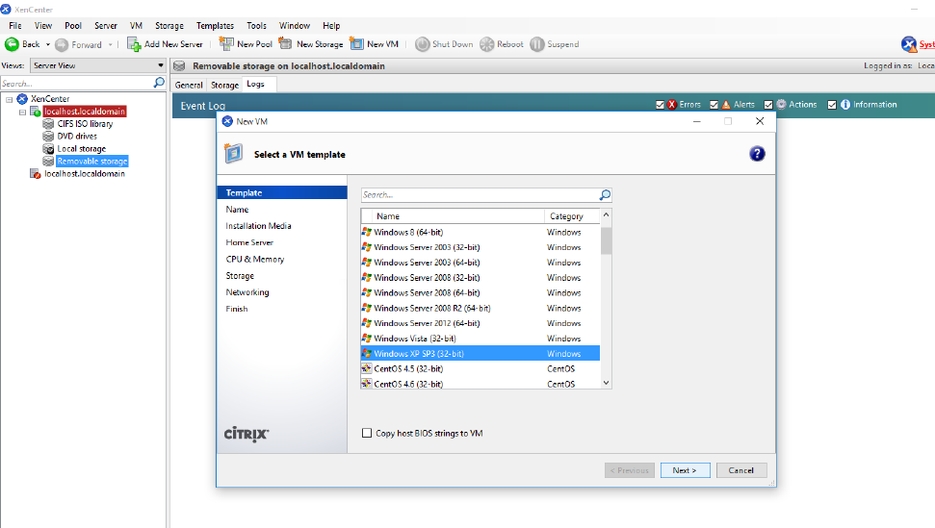

Select ISO file and click on next –

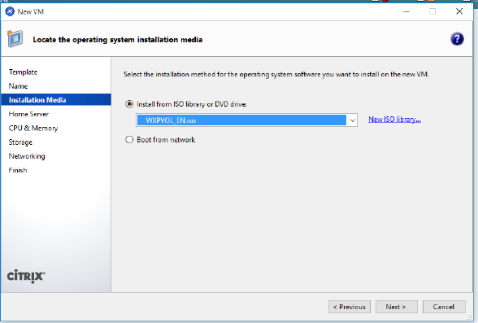

Click on “Next”.

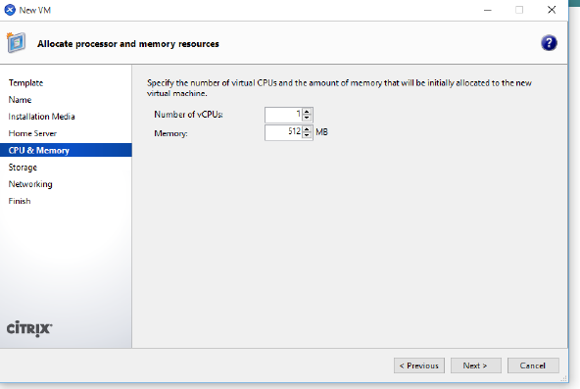

Click on “Next”.

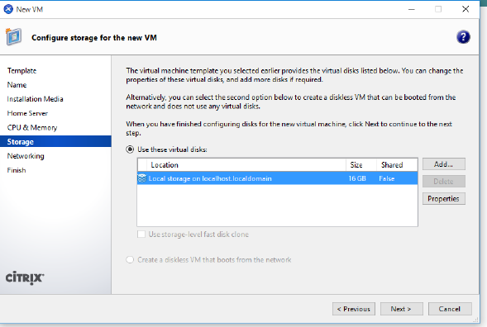

Click on “Next”.

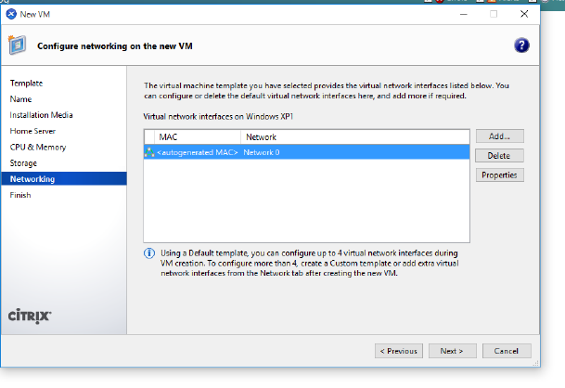

Uncheck – Start the new VM and click on create now

